SOFTWARE ENGINEERING  
LIBRARY MANAGEMENT  
SYSTEM  
 Name:p.swathi  
 Redgno:2023004583  
 component diagram  
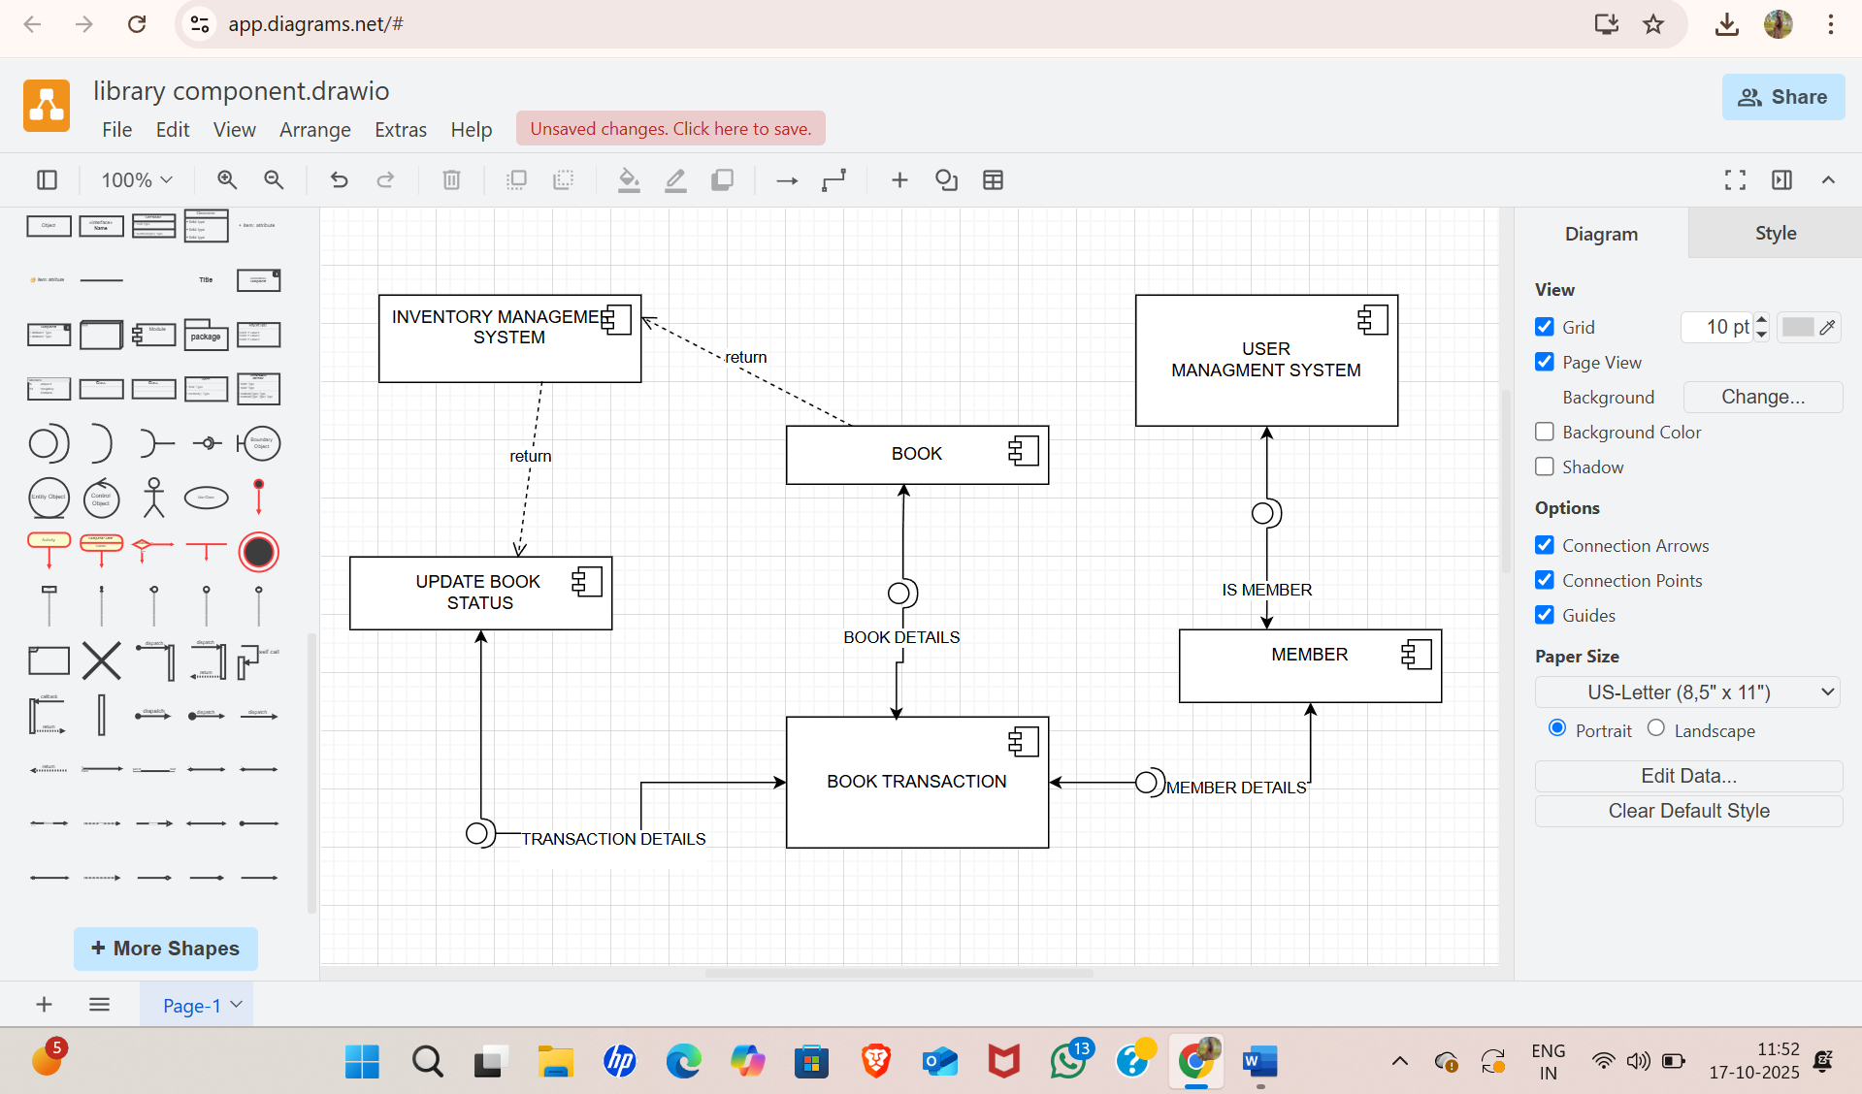

Deployment diagram  
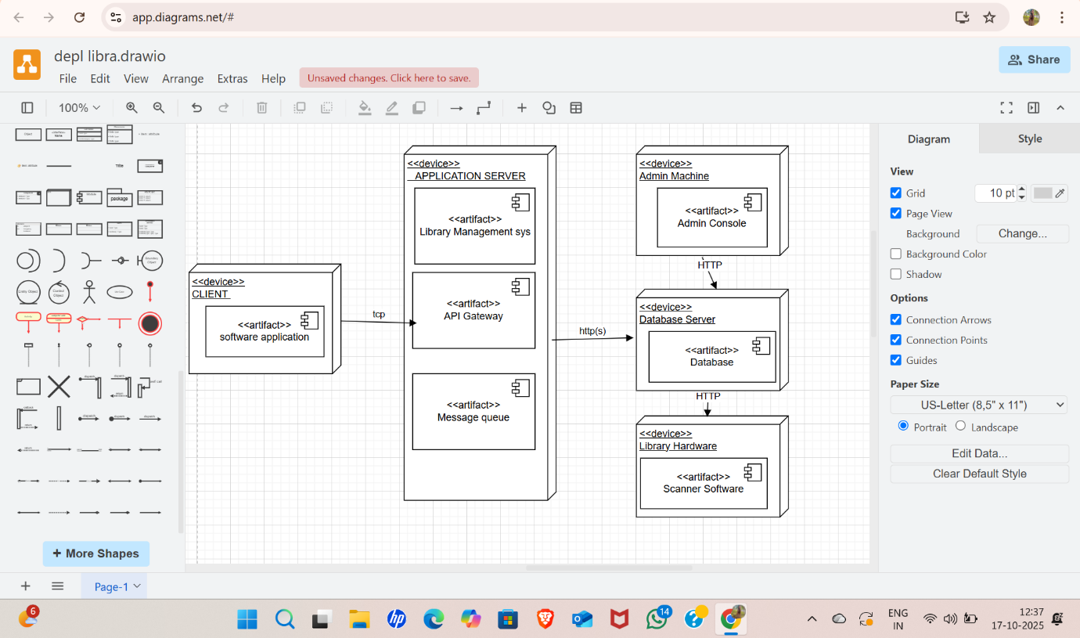

Collaboration diagram  
